*“Heaven’s Light is Our Guide”*



**Rajshahi University of Engineering & Technology**

**Department of Computer Science & Engineering**

**Lab Report**

**Course Code: CSE 3108**

**Experiment No:1**

|  |  |
| --- | --- |
| **Submitted By:** | **Submitted To:** |
| **Name: Farzana Haider**  **Roll: 2003026**  **Section: A**  **Year:3rd year Odd Semester** | **Name: Utsha Das**  **Lecturer**  **Department of CSE**  **RUET** |

**Name of the experiment:** Simulation of 2 to 4 decoder using Logisim Evolution software.

**Theory:**

A decoder is a combinational logic circuit that converts binary information from n input lines to a maximum of 2^n output lines. In this experiment, we focus on a 2 to 4 decoder, which takes two inputs and generates four outputs. The inputs represent a binary number, and the outputs indicate which one of the four output lines is active based on the input combination.

**Experiment :**

Truth Table:

|  |  |  |  |  |  |
| --- | --- | --- | --- | --- | --- |
| Input |  |  |  | Output |  |
| 0 | 0 | 1 | 0 | 0 | 0 |
| 0 | 1 | 0 | 1 | 0 | 0 |
| 1 | 0 | 0 | 0 | 1 | 0 |
| 1 | 1 | 0 | 0 | 0 | 1 |

**Output:**

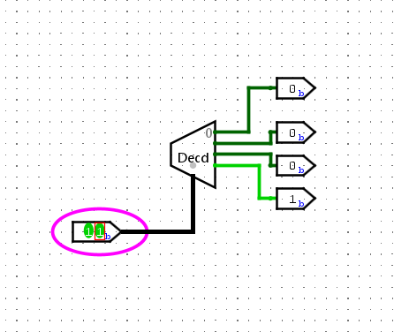

*“Heaven’s Light is Our Guide”*



**Rajshahi University of Engineering & Technology**

**Department of Computer Science & Engineering**

**Lab Report**

**Course Code: CSE 3108**

**Experiment No:2**

|  |  |
| --- | --- |
| **Submitted By:** | **Submitted To:** |
| **Name: Farzana Haider**  **Roll: 2003026**  **Section: A**  **Year: 3rd year Odd Semester** | **Name: Utsha Das**  **Lecturer**  **Department of CSE**  **RUET** |

**Name of the experiment:** Simulation of 4-bit Full Adder circuit using Logisim Evolution software.

**Theory:**  
A full adder is a digital circuit that performs addition of three input bits: A, B, and a carry input (Cin). It produces a sum output (S) and a carry output (Cout). In this experiment, we aim to design a 4-bit full adder.

**Experiment:**

Table:

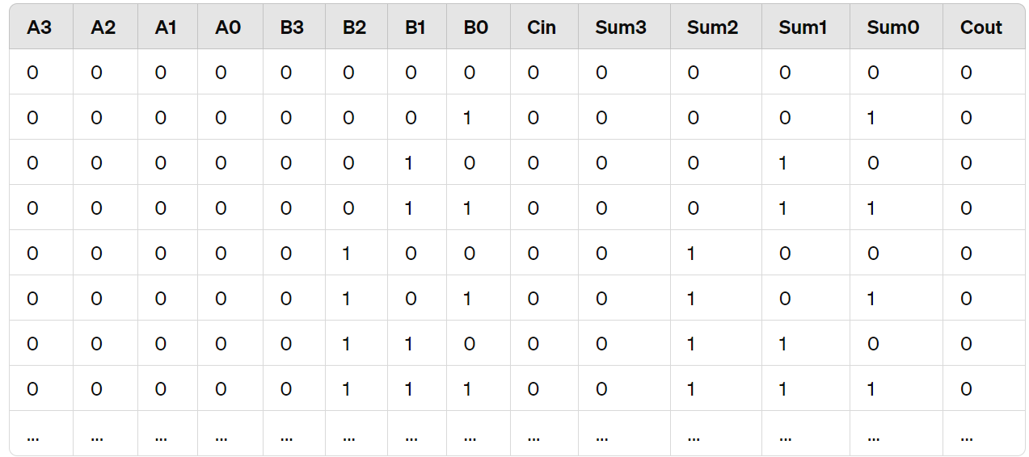

**Output:**

